***PORTFOLIO***

**COMPUTER SCIENCE AND ENGINEERING**

**Submitted by:**

**Name: Rishav Raj**

**Registration number: 12406759**

**Roll No.: RK24CTB64**

**Section: K24CT**

**Submitted to : Dr. Joshva Raj G**



**LOVELY PROFESSIONAL UNIVERSITY**

**DECLARATION**

I ,Rishav , a student of Bachelor of Technology under CSE discipline at Lovely Professional University, Punjab, hereby declare that all the information furnished in this project report is based on my own work and is genuine

RISHAV

Registrartion Number: 12406759

|  |  |  |
| --- | --- | --- |
| **Platforms for profile creation** | **Link to student profile** | **Screenshot** |
| ***Figma*** | <https://www.figma.com/files/team/1408363494915548018/recents-and-sharing/recently-viewed?fuid=1408363493336255> | 1 |
| ***Quora*** | <https://www.quora.com/profile/Rishav-Raj-1050> | 2 |
| ***Stack overflow*** | <https://stackoverflow.com/users/28010688/rishav-raj> | 3 |
| ***Hacker Rank*** | <https://www.hackerrank.com/profile/rishavraj19595> | 4 |
| ***Hacker Earth*** | <https://www.hackerearth.com/@rishavraj19595/> | 5 |
| ***Geeks for Geeks*** | <https://www.geeksforgeeks.org/user/rishavrajtap/> | 6 |
| ***LinkedIn*** | <https://www.linkedin.com/in/rishav-raj-91a502324/> | 7 |
| ***Github*** | <https://github.com/rishavraj19595> | 8 |
| ***CV*** | <https://drive.google.com/file/d/15RE8ZiEQ0LSb3tID_CeULsSMYV6Y_k0w/view?usp=sharing> | 9 |
| ***MOOCs*** | 1. | 10 |

1. **FIGMA**

**Profile:-**

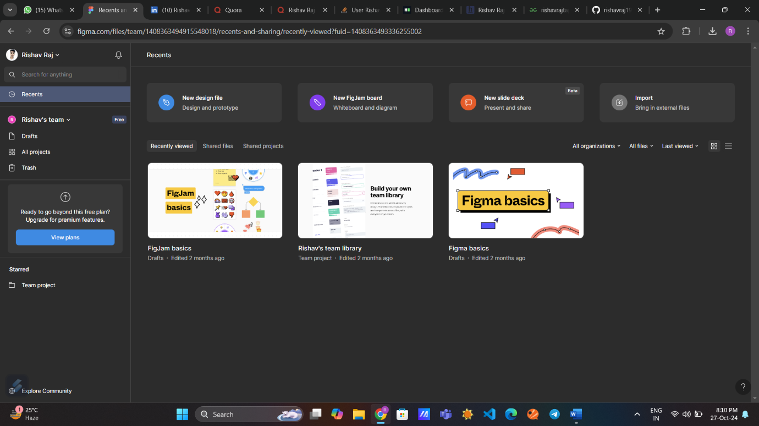

1. QUORA

PROFILE:-

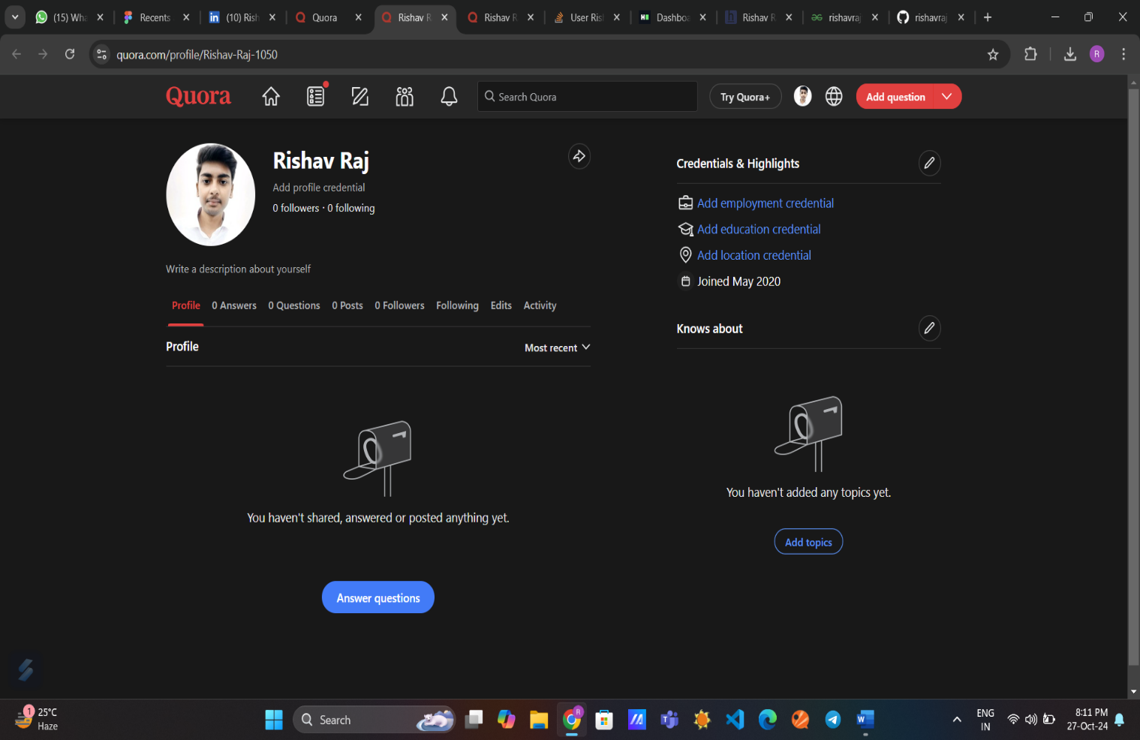

1. **STACKOVERFLOW**

**PROFILE:-**

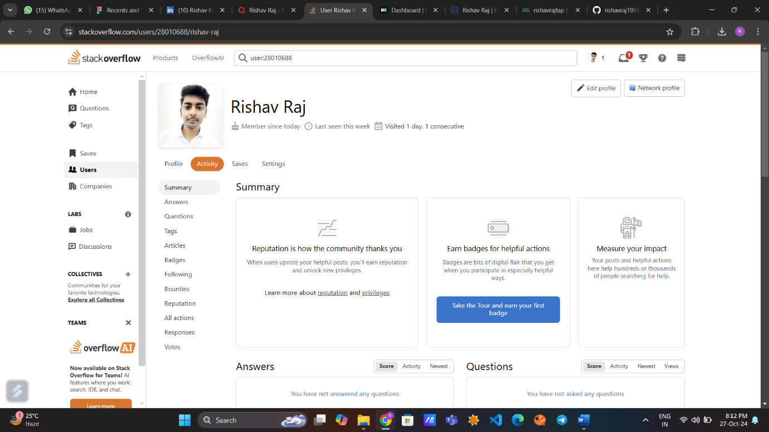

1. **HACKER RANK**

**Profile:** -

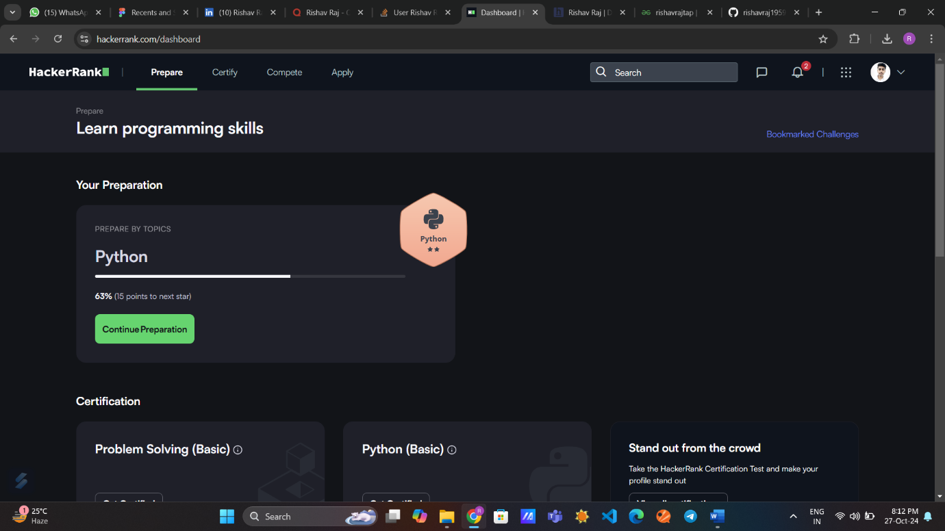

1. **HACKER EARTH**

**Profile: -**

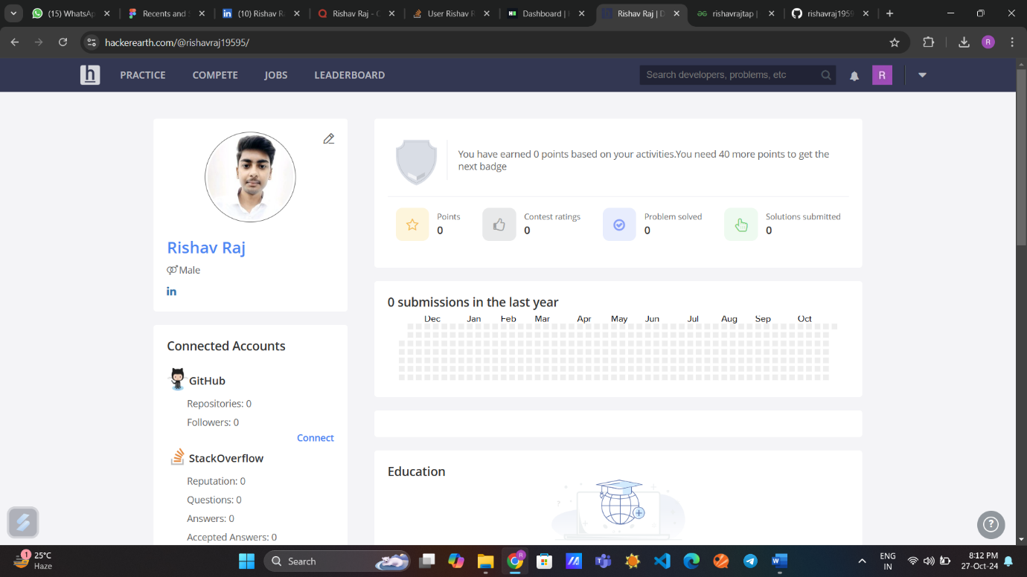

1. **GEEKS FOR GEEKS**

**Profile:-**

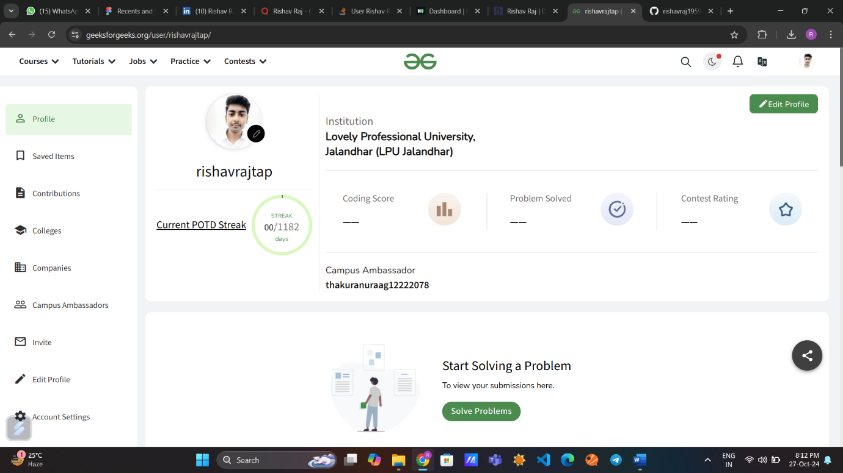

1. **GITHUB**

**Profile:**

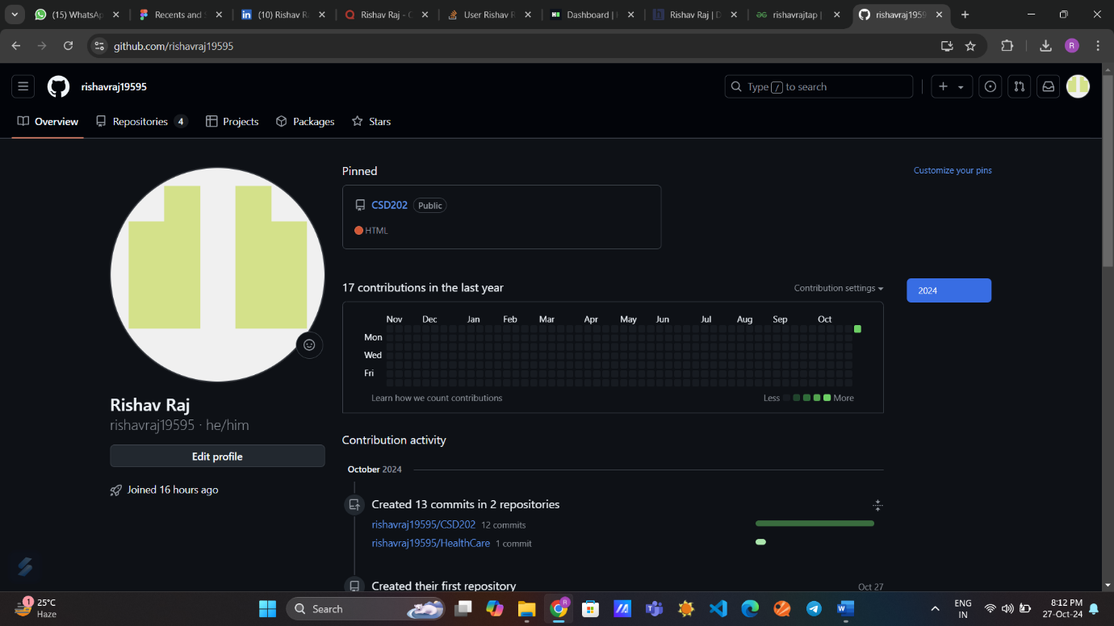

1. **CV**

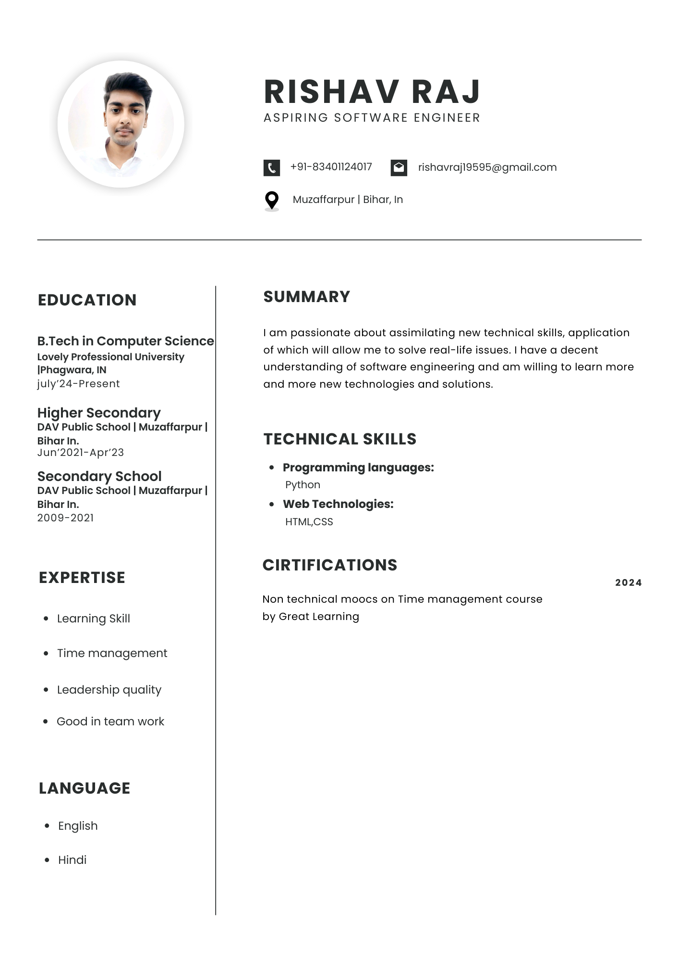

1. **MOOCS completed**

